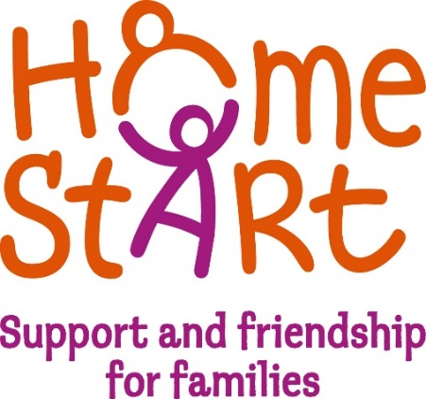

Home-Start South & West Devon

Volunteers wanted in your area
Do you remember:
- Sleepless nights
- Teething
- Toddler tantrums
- Finding parenting a challenge

Then you could be a great volunteer!
All you need is parenting experience, listening skills, and the desire to support other parents who are going through a tough time
We need you
Volunteers receive free initial training and once matched to a family visit them once a week for a couple of hours
Meet new people, gain experience, build your CV
Our next training course starts soon. Expenses are paid
If you are interested contact - 01752 249740

