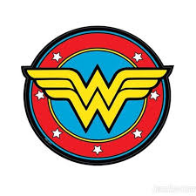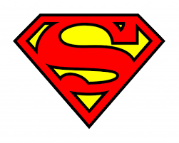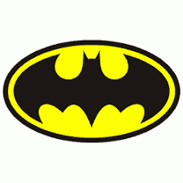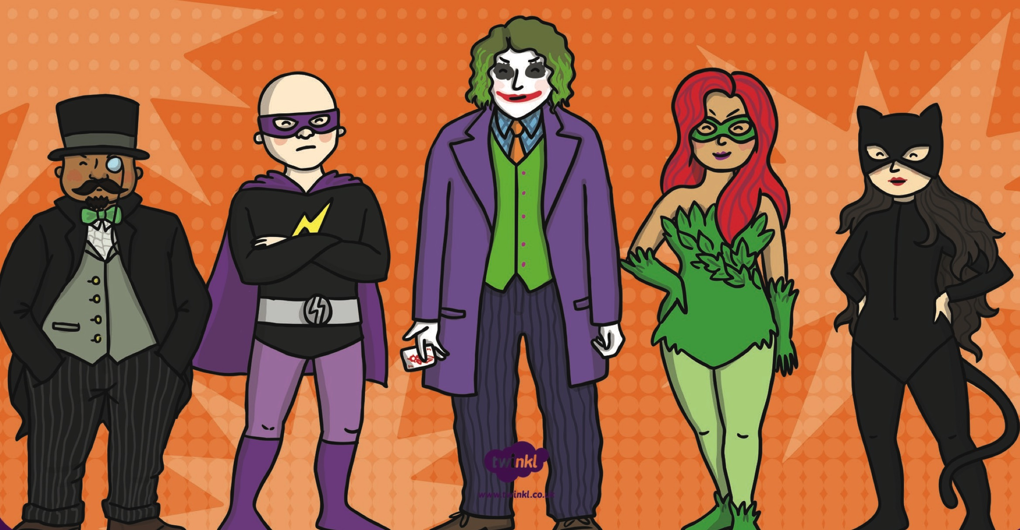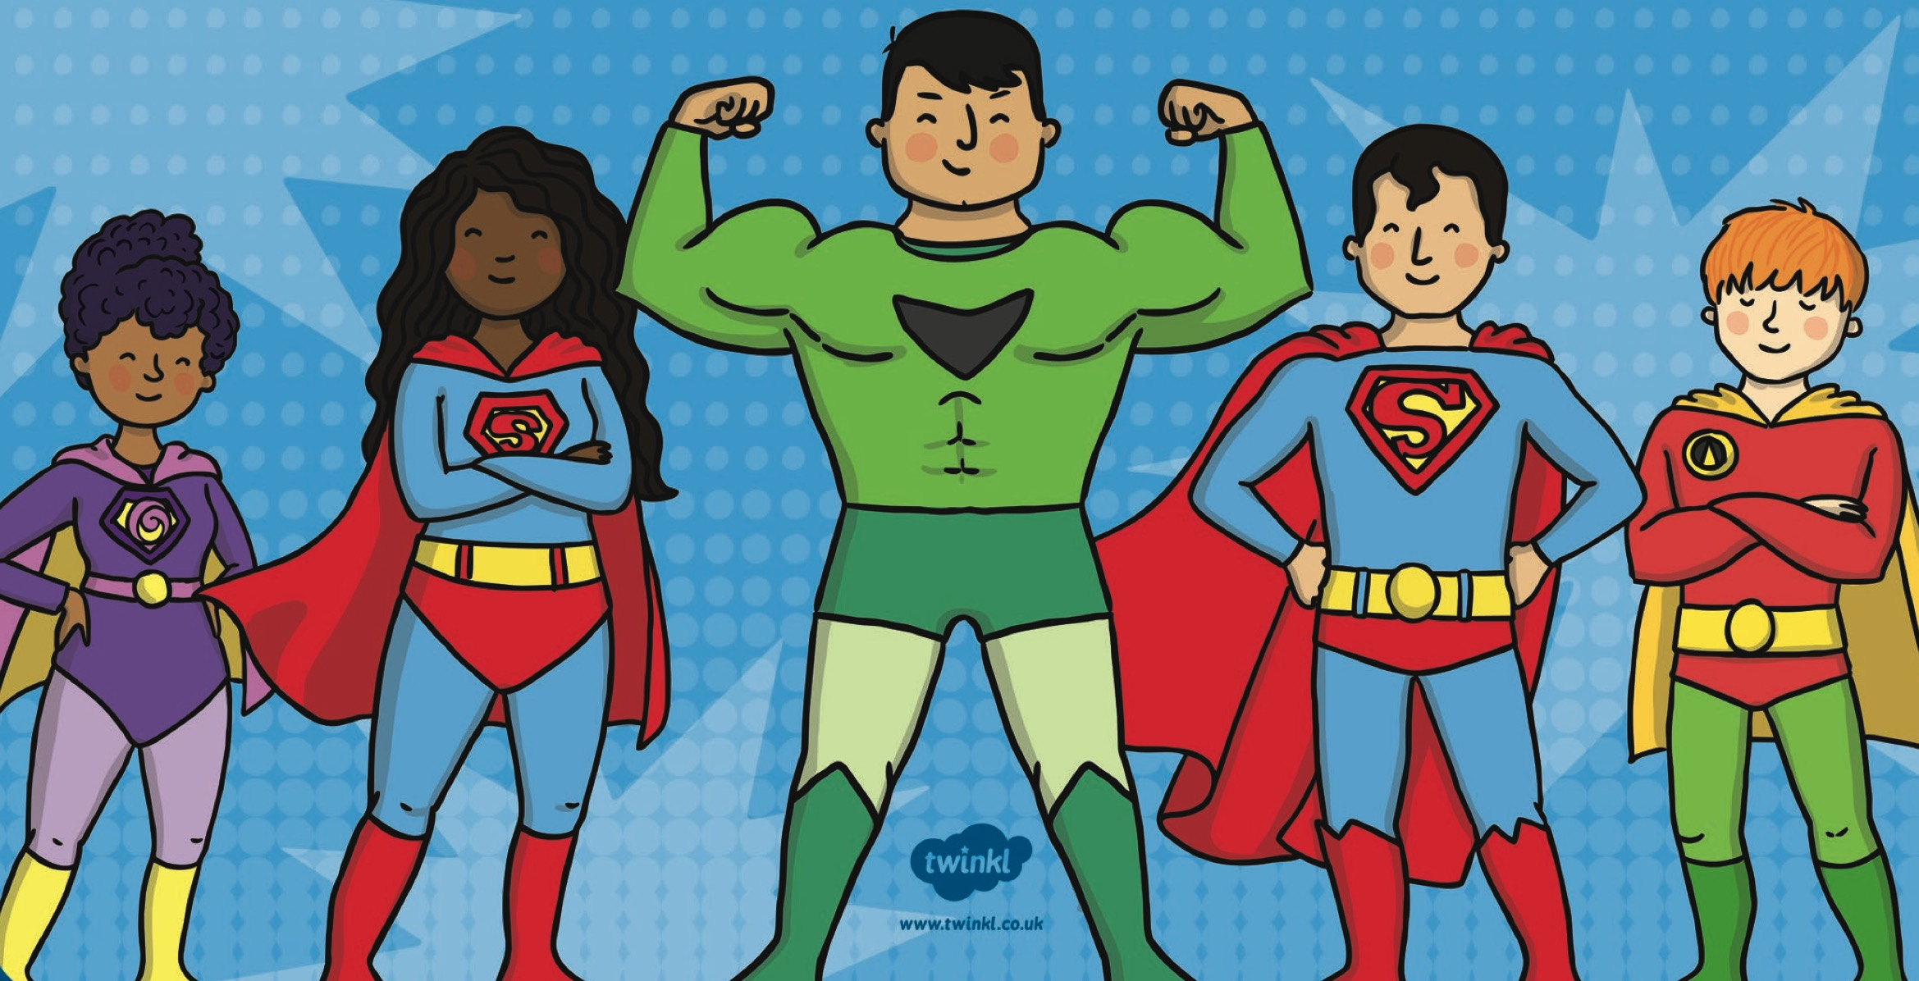

Science

This term in Science the children will be learning about everyday materials. They will have opportunities to sort, group and describe these materials based on their properties. The children will then be challenged to create part of a superhero costume based on what they have learnt.

Maths

In Maths this term the children will continue to develop their knowledge of addition facts through Big Maths. They will also explore a range of problems involving shape, position, time and measure. The children will begin to measure and record the length, height, weight and capacity of different objects. They will learn to tell the time to the hour and half past. The children will also use what they have learnt about multiplication and apply that to division, using both practical and pictorial representations.

**English**

In English this term will kick of with writing adventure stories based on Giles Andre’s ‘Nat Fantastic’. The children will also have the opportunity to share, hear and discuss a range of other exciting fiction and non-fiction texts to inspire their writing. They will continue to build on their existing phonic knowledge to improve their ability and spell words accurately. There will be a focus on speaking and listening to develop the children’s vocabulary and provide them with the skills to write in a variety of exciting contexts. Additionally, children will learn to check their own writing for simple mistakes such as missing capital letters, full stops, finger spaces exclamation marks and question marks.

**Physical Education**

In PE this term the children will learn to master basic movements including running, jumping, throwing and catching, as well as developing balance, agility and co-ordination. They will begin to apply these in a range of activities through participating in team games, developing simple tactics for attacking and defending as well as performing dances using simple movement patterns.

**History**

In History this term the children will learn about the life of the real life hero, Florence Nightingale. They will discover how her life contributed to life today and then compare how her life as a nurse is different to that of a nurse today.

**Design Technology**

In DT the children will be designing purposeful, functional, appealing products for themselves and other users based on design criteria. They will generate, develop, model and communicate their ideas through talking & drawing. The children will select from and use a range of tools, equipment, materials and components to perform practical tasks. Finally, they will evaluate their ideas and products.

**Heroes and Villains!**

**Year 1: Summer**

**Computing**

During computing the children will use technology purposefully to create, organise, store, manipulate and retrieve digital content. They will learn what algorithms are and how they are implemented as programs on digital devices. They will also create and debug simple programs using logical reasoning to predict the behaviour of simple programs.

**Art and Design**

This term the children will use a range of materials creatively to design and make products. They will learn to use drawing painting and sculpture to develop and share their ideas, experiences and imagination. The will develop a wide range of techniques in using colour, pattern, texture, line, shape, form and space. Their learning will be enhanced through incorporating the work of a range of artists craft makers and designers.