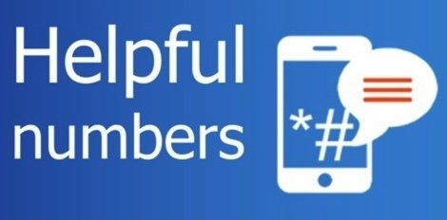
Useful Numbers …
NHS – 111
Police –non emergency 101
www.gov.uk/guidance/coronavirus-covid-19-information-for-the-public
www.gov.uk/government/organisations/department-of-health-and-social-care
Social Services and Early Help Advice - gateway@plymouth.gov.uk 01752 668000
NSPCC 08088005000 useful information for parents and child
Childline 08001111
The Urgent Mental Health Support Telephone line is open now 24 hours a day, 7 days a week on 01752 435122 for advice and support. Is your child or the child you are caring for experiencing anxiety, worry or stress? Are they experiencing psychological or emotional distress? This service is open to Children, Young People, Parents, Carers and Professionals
Plymouth Food Bank via One stop shop 668000
Citizen Advice- benefit advice 03003309043
CAB advice line 03444111444
Samaritans 116123
Plymouth Domestic Abuse 01752 252033 www.nationaldahelpline.org.uk
www.relate.org.uk/relationship-help/covid-19-advice-and-information
One Stop Shop – Advice on housing, council tax benefits, council services 01752 668000
Money Advice Plymouth –for debt advice 01752 208126
Family Group Conference and Mediation 01752 306861 Harbor Centre 01752434343

Please see our school website for further information

