Programme of work for this term
English |  | Maths | Science
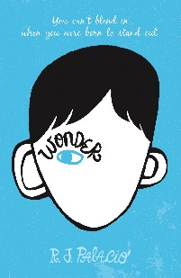  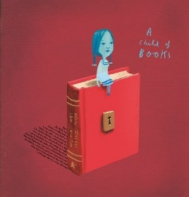  We will start Year 6 by holding a reading day based around the text, ‘A Child of Books.’ We hope to inspire children to have a love of reading. Children will recommend books they have read and encourage others to love them too!  Our text for English will be ‘Wonder.’ We will use this in guided reading and as inspiration for our writing. The first text type we will study are diaries and we will write as the main character from Wonder.  Connected to science we will write an information text about the heart. Other texts include persuasion, poetry and narrative. |  | The first term will begin with a focus on calculation, allowing the children time to consolidate strategies for solving the four main mathematical operations.  As we believe it is important for children to use their skills in real life scenarios, where possible, they will be given the opportunity to practise their mathematical skills across the curriculum, i.e. scale work with maps, graph work in science etc.  We revise: addition, subtraction, multiplication and division, perimeter and area, measure, shape and space, and word problems. | Our science topic this term is Healthy Humans.  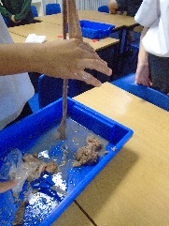  The children will wonder about the human body, learning how the heart and digestive system works as well as thinking about the benefits of a healthy diet and exercise. Children will experience a heart dissection when they are visited by teachers from a local secondary school. They will also take part in the notorious ‘poo experiment’ as they explore practically how the digestive system works.  They will also consider the negative effects of smoking, alcohol and drugs on the body.
Fight for Freedom Topic – History and Geography |  | Art and Design & Technology | French
Our exciting new topic for this term is ‘Difference’. Using the book ‘Wonder’ as inspiration, the children will consider how the main character was discriminated against. They will then research injustice in history finding out how people have been discriminated against for various reasons, including gender, race or beliefs.  The children will also learn about their rights, using the United Nations Conventions on the rights of a child to understand what children should be entitled to. Children will consider modern-day injustices and how they can be kind. On World Kindness Day (November 13th) children will carry out acts of kindness. |  | 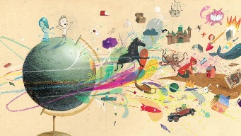  In connection with our reading day based around ‘A Child of Books’, children will explore the fantastic illustrations by Oliver Jeffers and Sam Winston. They will use this as inspiration for their own artwork. | Children will be introduced to French where they will learn to understand and respond to spoken and written language. They will learn to speak with increasing confidence, fluency and spontaneity using, stories, songs and rhymes. They will also be taught the grammatical structures of the language to aid their accuracy of pronunciation.
Physical Education | Computing | Religious Education | Music
During the Autumn term, Year 6 are lucky enough to be supported by Plymouth Argyle Football Club. Members of the club will come and lead football and rugby coaching during outdoor PE sessions.  We will follow a gymnastics programme for one half term focussing on specific skills and enabling progression and peer assessment. | Computer skills will be developed and used throughout our ’Wonder’ topic.  The children will use the Internet to research and present information about injustices in history.  Children will continue to learn about the importance of e-safety. | This term, children will get the opportunity to discuss some big questions such as "Is God real?"  They will look at a variety of beliefs about creation and how a scientific view can contrast with this. | In the Autumn Term, Year 6 music lessons are closely linked to the ’Differences' topic and the injustices people have experienced in history. We begin by extending our rhythm reading skills with chair drumming sessions.  We perform songs of slavery and freedom with instrumental accompaniment and then look at how these songs shaped musical history through to the blues and jazz. Through this, we will be improving our ability to sing in parts.  .

