National Trust’s Safety Guidance

Safety is really important to us, and there are lots of tips on how to become a 50 things expert safely on each of the activity pages in the 50 Things book.
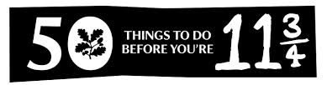

General advice for parents/ careers:

- When dealing with soil, animals or natural water source make sure any cuts or wounds are covered with waterproof plasters to avoid infection.
- Discourage your child from putting anything in his or her mouth.
- Wash your child's hands thoroughly afterwards.
- Make sure your child wears warm, weather resistant clothing during any activities involving water or snow.
- Make sure your child wears suitable footwear for any activities that may involve slippery or uneven surfaces.
- Check weather reports before any activity and avoid trees or natural water sources in wet or windy conditions.
- Supervise children at all times during these activities.
- For more challenging activities, find an organised event to ensure the safest conditions for your child.

Additional safety information and links to other website* are available on:

www.50things.org.uk/parents-area

*Please note that while we've made every effort to check the websites we included, content may change and we cannot accept responsibility for third party sites.

Please note that if you visit www.50 things.org.uk and create an online account, core safety information is also provided on each of the 50 things activity pages.

