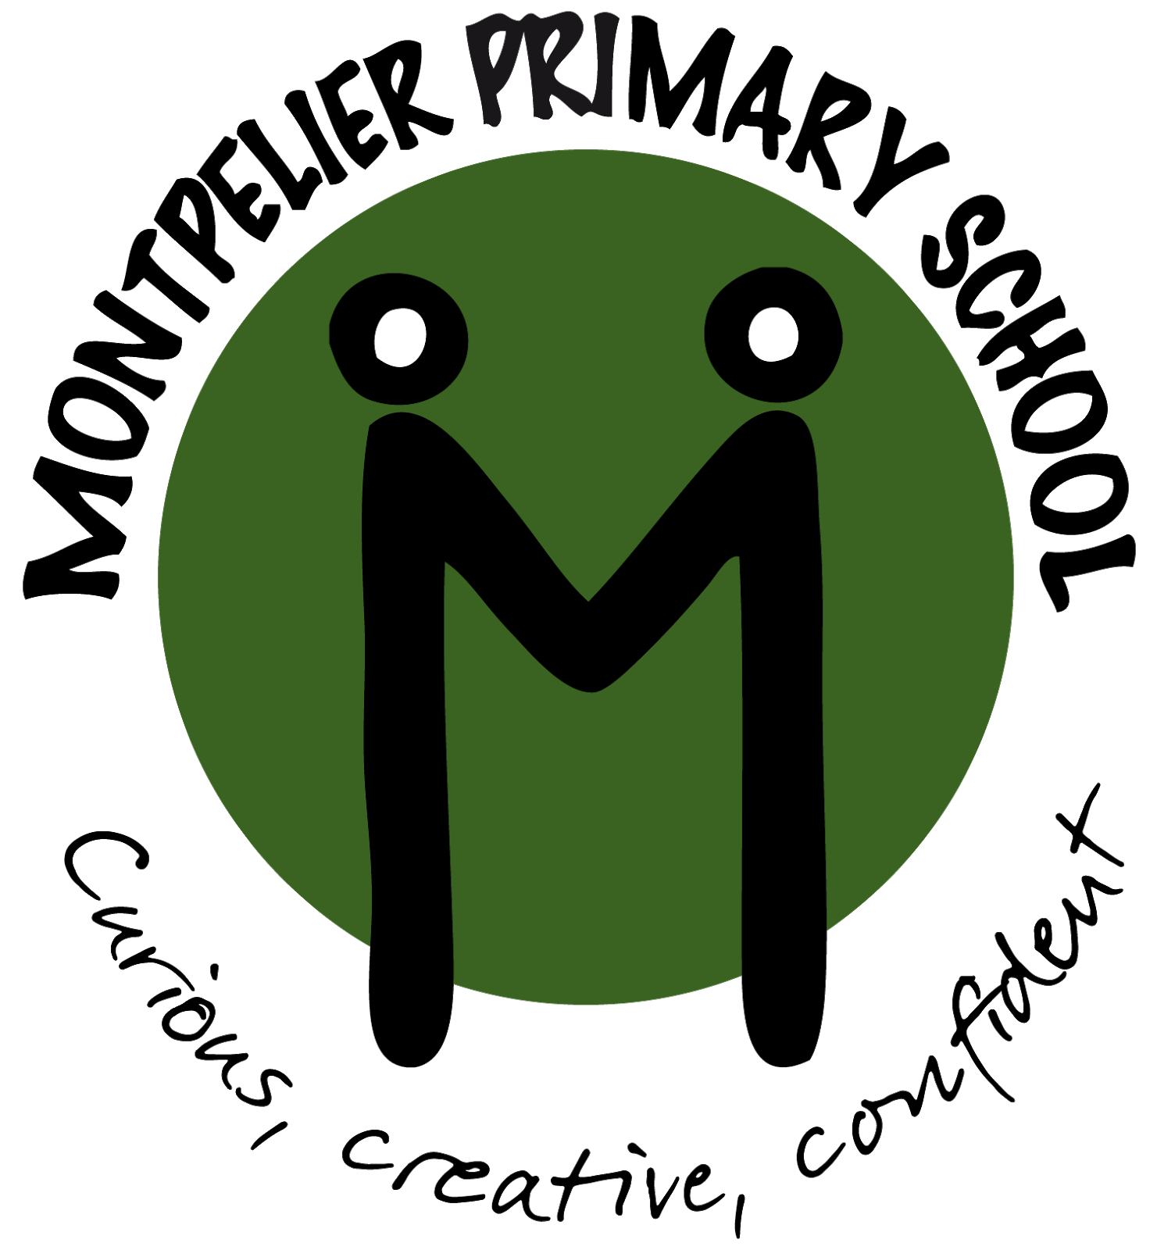

Welcome to Year 2!

We are very excited to start a fresh school year and are determined to make the children’s learning experiences extremely fun, special and memorable! We will start the year by getting to know our new classes and settling them back into school life, consolidating some of their Year 1 learning as well as getting stuck into our Year 2 curriculum.

Topics

For the first half term, our topic will be…

**Dinosaur Discovery**

We will then move on to

**Around the World**

Full details of each topic will be

available on the school website.

PE

Year 2’s PE days are: **Monday, Tuesday, Wednesday and Friday.** The children need to come into school wearing their PE kit on a **Tuesday ONLY**.

2M Mrs Pascoe [class2M@mpsplymouth.net](mailto:class2M@mpsplymouth.net)

2P Miss Card

[class2p@mpsplymouth.net](mailto:class2p@mpsplymouth.net)

2S Mr Wright [class2S@mpsplymouth.net](mailto:class2S@mpsplymouth.net)

Miss Tapp

Mrs Landricombe

Meet The Team!











Home Learning

We will not be sending home reading records this year, however, please continue to read with your child as often as possible, this is vital to your child’s development and will support them with all areas of their learning. As a school, we recommend that an adult should read with a child at least x3 a week. Children will bring books home to share with you. Please send in pictures or videos of your child reading at home to their class teachers’ email address. Look out for a special cuddly visitor visiting your home as part of our reading incentive for the children- ‘Read-o-saurus’. Children will be taught a new spelling rule each Monday and spellings will be sent out that evening for them to practice at home. A WOW Write will take place the following Monday. We will also be teaching the 2,5 and 10 multiplication tables this year in fun and exciting ways, moving onto the 3’s towards the end of the academic year. If your child would like some extra home learning opportunities linked to our topic, please see Google Classroom. Your support in helping your child to learn their spellings and times tables at home is invaluable – thank you!

Questions & Queries

Please see a member of the Year 2 Team on the door if you have any immediate questions or call the school office. For non-urgent matters please email your child’s class teacher and we will get back to you as soon as we can.





Mrs Roberts

