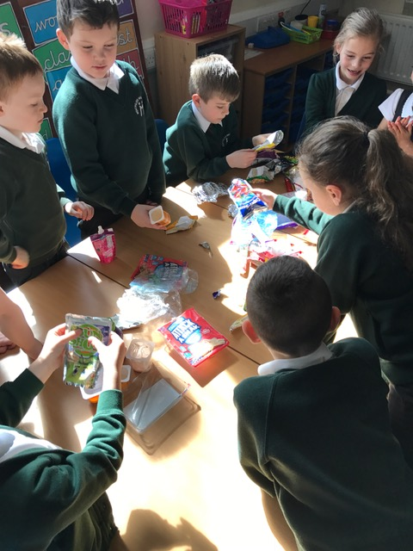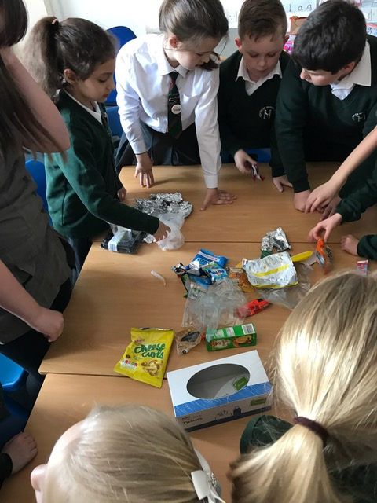

Eco Council Meeting 22.3.17

Attended

Full attendance today apologies from Vikhat R 2P

Full attendance apart from 3M Jake N, 3P Bradley B, 3S Olivia C, 4M Tobi H, 5P Adela C and 5P Ethan H.

Thank you for all your support in reminding the children of their Eco Council commitment.

**Action**

Today in Eco we sorted out packaging left over from our packed lunches. The children collectively sorted then into piles of Reuse, Reduce and Recycle. We looked at the recycling symbols on the reverse of the packaging which were of great interest to the children. We then discussed what we could reuse and many interesting ideas were offered. It was great fun and informative.

**Next Meeting 29.3.17**

We have been invited to the Music Room to listen to some Eco Raps composed by our Y6 children. Fantastic!