Do you like to sing? Do you like to have fun with friends?
Are you aged between 4 and 18? Is someone in your family in the Armed Forces or a Veteran?
Come and join
The Military Kids Choir

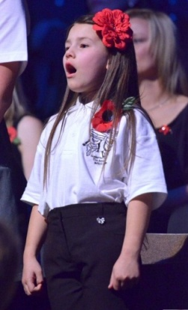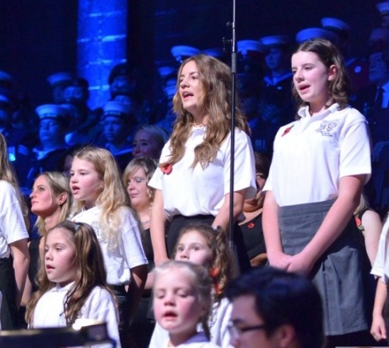

The Military Kids Choir is part of MKC Heroes. We meet on Wednesdays, in Plymouth Guildhall, from 5pm to 6pm, to sing together and have fun as a team. We perform at events all over Plymouth and help charities to raise money, especially the Royal British Legion. The choir is free to join and parents/carers can drop you off for practices or can stay for tea or coffee whilst you are having fun. (All staff have DBS Checks)

To find out more, contact MKC Heroes by emailing heather.ogburn@plymouth.gov.uk or call Heather at MKC Heroes on 01752 307445 or 01752 779657
You can also join us by coming to our first autumn practice on:
September 20th 2017 or our open ‘taster’ practice on September 27th 2017

